

**HR Life Care**

Names : Hudallil Muthaqin(1820010092)

Raudhiatul Ridwan(1820010181)

Class : 4SC5

Faculty : Mr. Fachran Nazarullah

**CEP-CCIT**

**FAKULTAS TEKNIK UNIVERSITAS INDONESIA**

**2020**



**Developed By**

1. **Hudallil Muthaqin**
2. **Raudhiatul Ridwan**

**PROJECT ON**

*HR Life Care*

Batch Code : 4SC5

Start Date : 25-04-2020

End Date : 30-04-2020

Name of Faculty : Mr. Fachran Nazarullah

Name of Developer:

1. Hudallil Muthaqin
2. Raudhiatul Ridwan

Date of Submission: 07-05-2020

**Quiz!**



**CERTIFICATE**

This is to certify that this report titled “HR Life Care” embodies the original work done by Hudallil Muthaqin and Raudhiatul Ridwan. Project in partial fulfillment of their course requirement at NIIT.

Coordinator:

Mr. Fachran Nazarullah

Praise be to Allah Almighty, Most Merciful, because thanks to His grace and guidance, the writer can arrange and present a paper that contains about HR Life Care. The writer also thanked to Mr. Fachran Nazarullah as lecturer Introductory IT courses that have provided guidance to the writer in the process of preparing this paper. Not to forget the writer thank the various parties who have given encouragement and motivation.

The author realizes that in the preparation of this project there are still many shortcomings and far from perfection. Therefore, the authors expect constructive criticism and suggestions to improve this paper and can be a reference in preparing the papers or subsequent tasks.

The authors also apologize if in writing this paper there are typos and errors that confuse the reader in understanding the author's intent.

.

**ACKNOWLEDGEMENT**

**System Summary:**

HR Life Care is a website that shows all that is in our hospital. From good infrastructure, experienced doctors, hygienic operation rooms, and digital control centers. As well as our website has a feature that can make appointments with the desired doctor and hospital working hours.

**SYSTEM ANALYSIS**

1. VS Code

Visual Studio Code is a source-code editor developed by Microsoft for Windows, Linux and macOS. It includes support for debugging, embedded Git control and GitHub, syntax highlighting, intelligent code completion, snippets, and code refactoring. It is highly customizable, allowing users to change the theme, keyboard shortcuts, preferences, and install extensions that add additional functionality. The source code is free and open-source, released under the permissive MIT License. The compiled binaries are freeware for any use.

**TOOLS USED**

User Interface Website Preview using Screenshot:

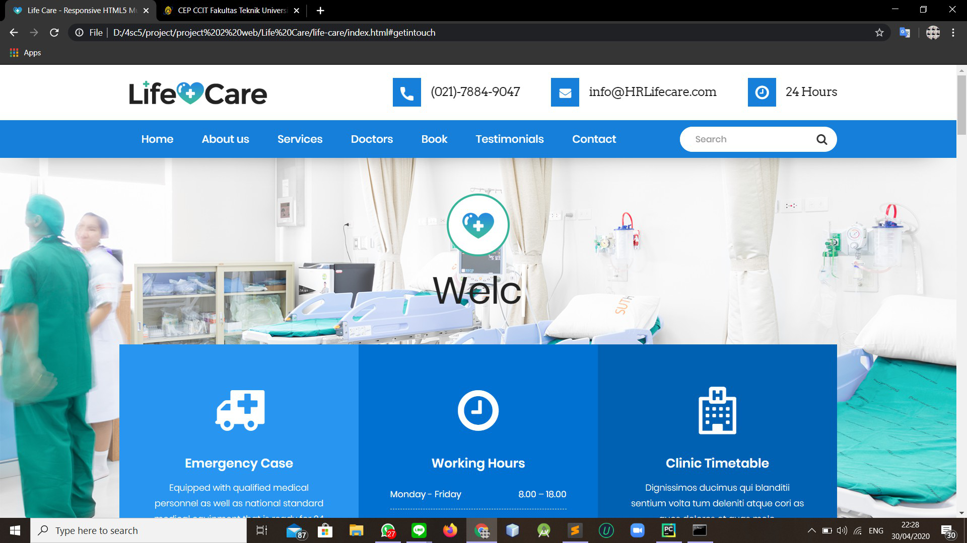

Home Page (Desktop)

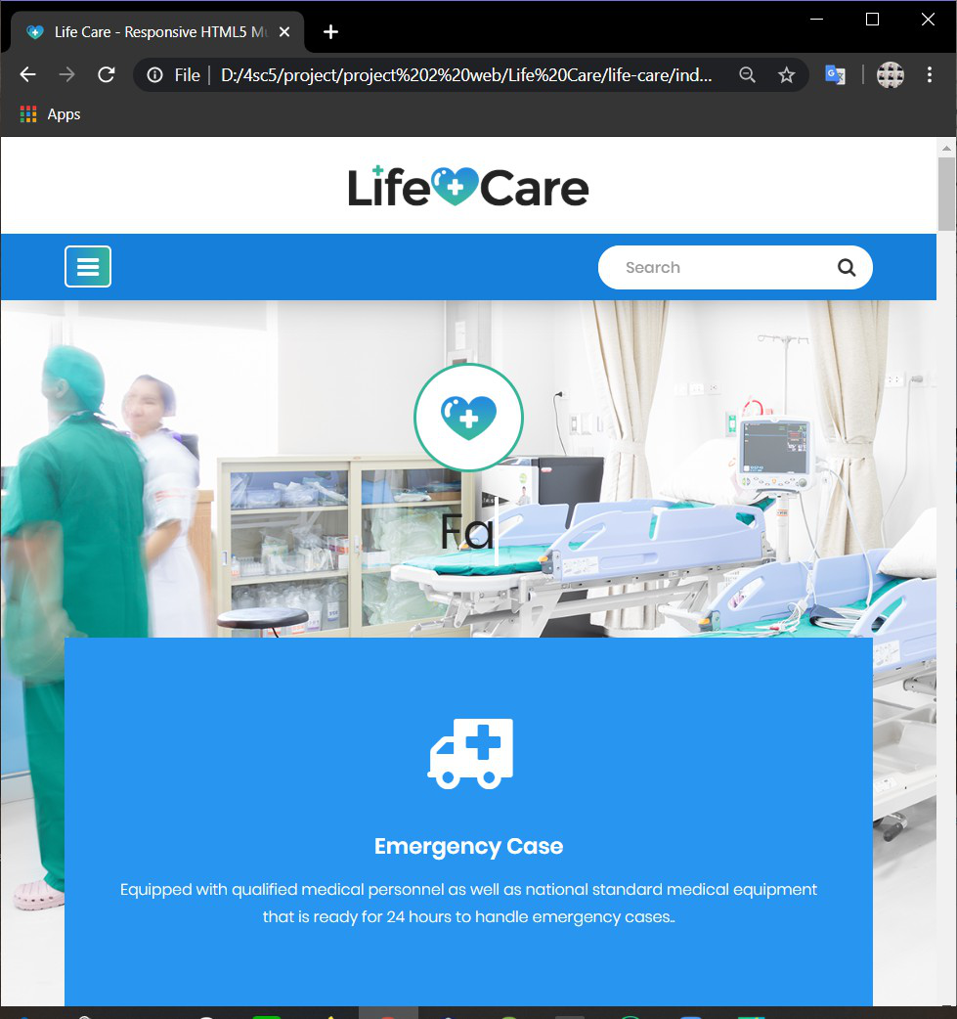

Home Page (Mobile)

**PREVIEW OF USER INTERFACE**

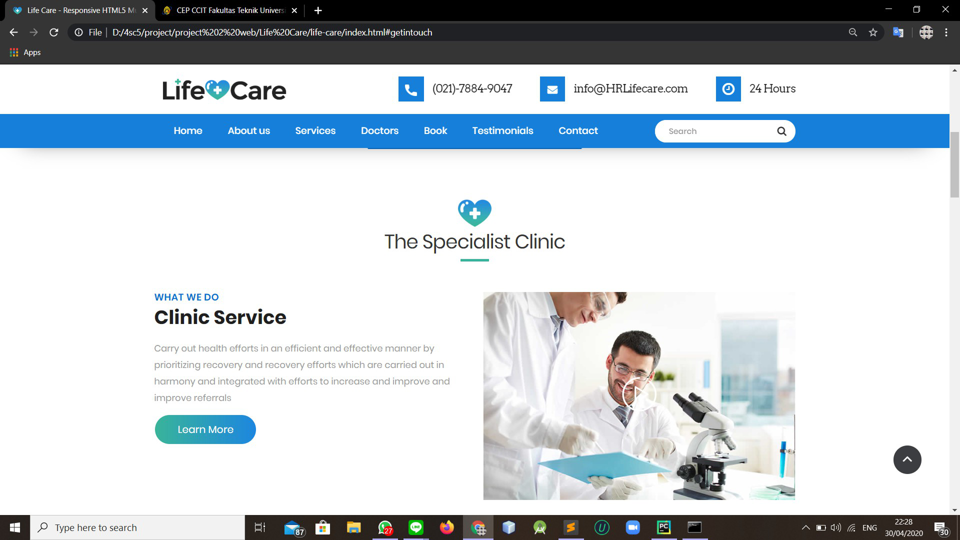

Clinic Service (Desktop)

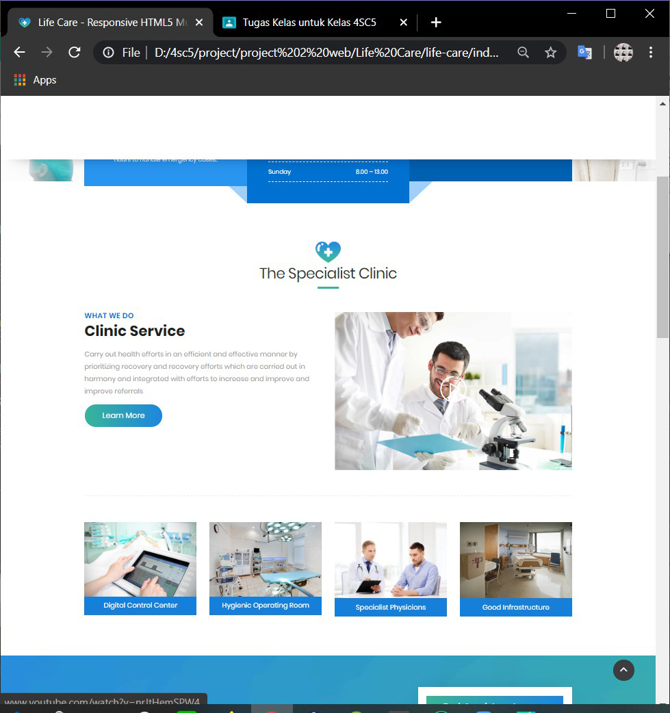

Clinic Service (Mobile)

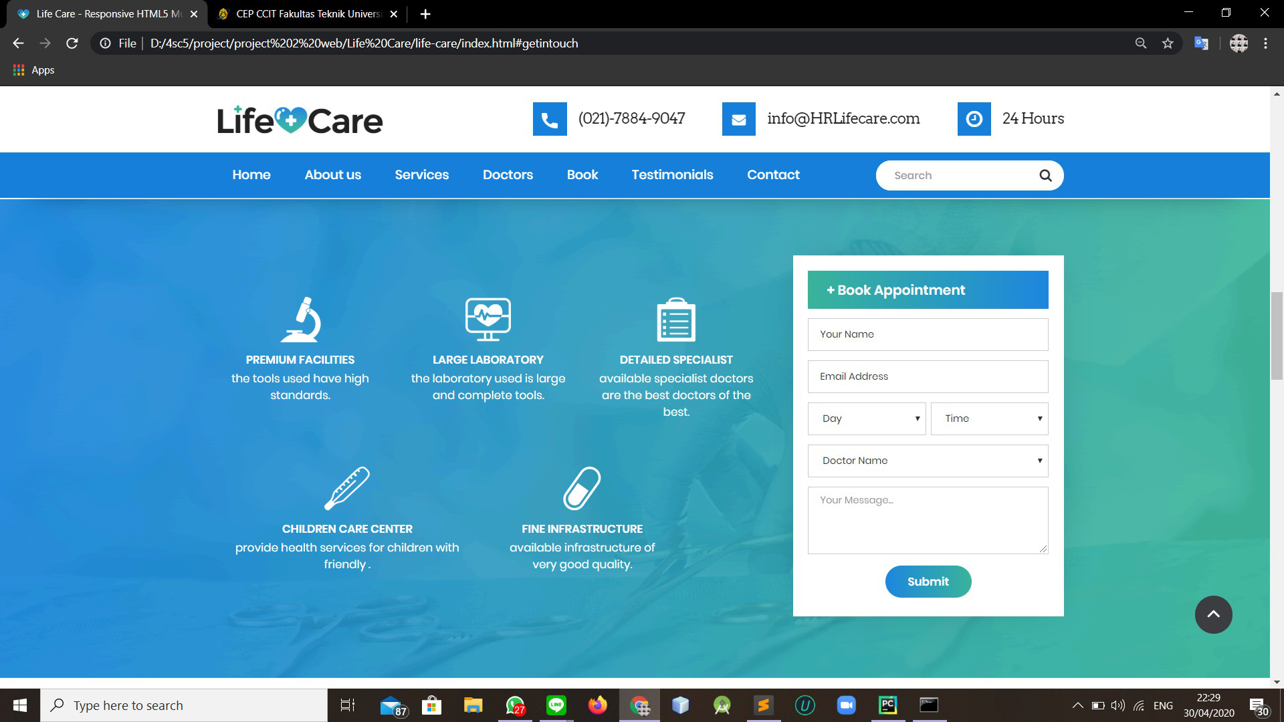

Book Appointment (Desktop)

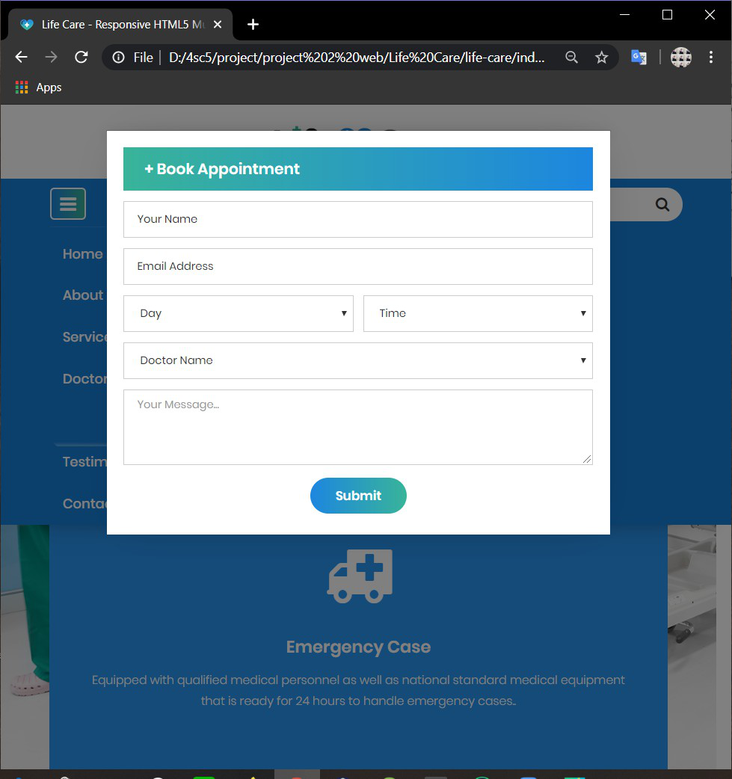

Book Appointment (Mobile)

|  |  |  |  |  |
| --- | --- | --- | --- | --- |
| *No* | *Action Description* | *Planned of Date Completion* | *Actual Date* | *Remarks* |
| 1. |  |  |  |  |
| 2. |  |  |  |  |
| 3. |  |  |  |  |

**ACTIVITY LIST**

**Hardware :**

HP Pavilion x360 14-dh0xxx, i7-8565U CPU @ 1.80GHz 1.99GHz RAM 8,00GB 64-bit.

Dell Inspiron 14 7000 i7-8550u CPU @ 1.80GHz RAM 8,00GB 64-bit

**Operating System :**

Microsoft windows 10

**Software :**

VS Code

|  |  |  |
| --- | --- | --- |
| **PROJECT FILE DETAILS** | | |
| No | File Names | Remarks |
| 1 | HR Life Care | Contain 1 Pages |

**CONFIGURATION**